User Manual

EECS 2311 | Software Development Project

Group 4:

Walid AlDari

Hoshner Tavadia

Shaharyar Choudhry

Matthew Patrus

**About** **3**

Program Name and Use 3

Features 3

**System Requirements** **3**

**Installing TAB2XML Using Gradle** **4**

**How To Use The Program** **7**

**Input Requirements** **12**

5.1 Measure instructions (Repeats and time signature) 12

5.2 Guitar 14

# 

# About

## Program Name and Use

TAB2XML is a program designed to convert text tablature into musicXML. It also has some new features which include producing music tablature sheets and a built-in music player.

## Features

The TAB2XML program can currently perform the following:

* Convert text tablature to musicXML
* Convert text-based tablature to tablature sheet music
* Export the tablature sheet music into PDF Documents.
* Play text-based tablature using an in-built player

# System Requirements

|  |  |
| --- | --- |
| Available Disk Space | 75 mb |
| RAM | 500 mb |
| Java Version | Java 17 |
| Operating System | Windows, MacOS (Excluding the m1 powered ones), Ubuntu, Any platform with gradle |

# 

# Installing TAB2XML Using Gradle

1. Open up the eclipse program, and select file>Import

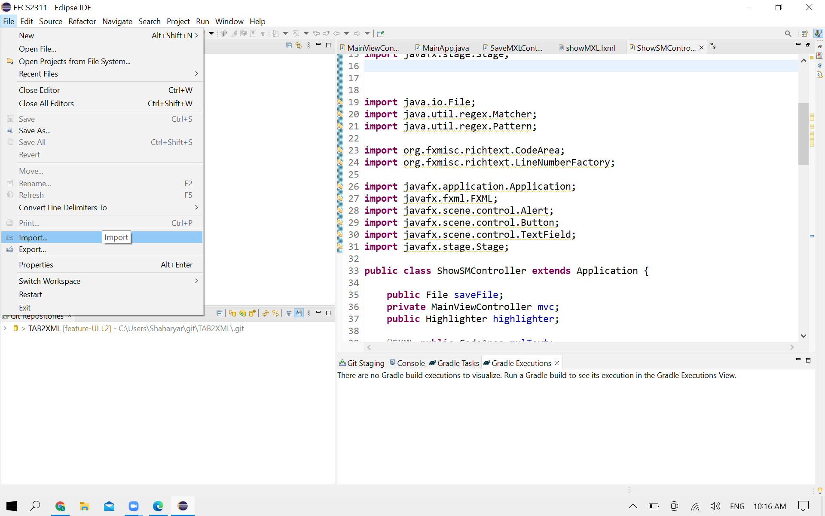

1. Select Git>”Projects from Git(with smart import)” and click next

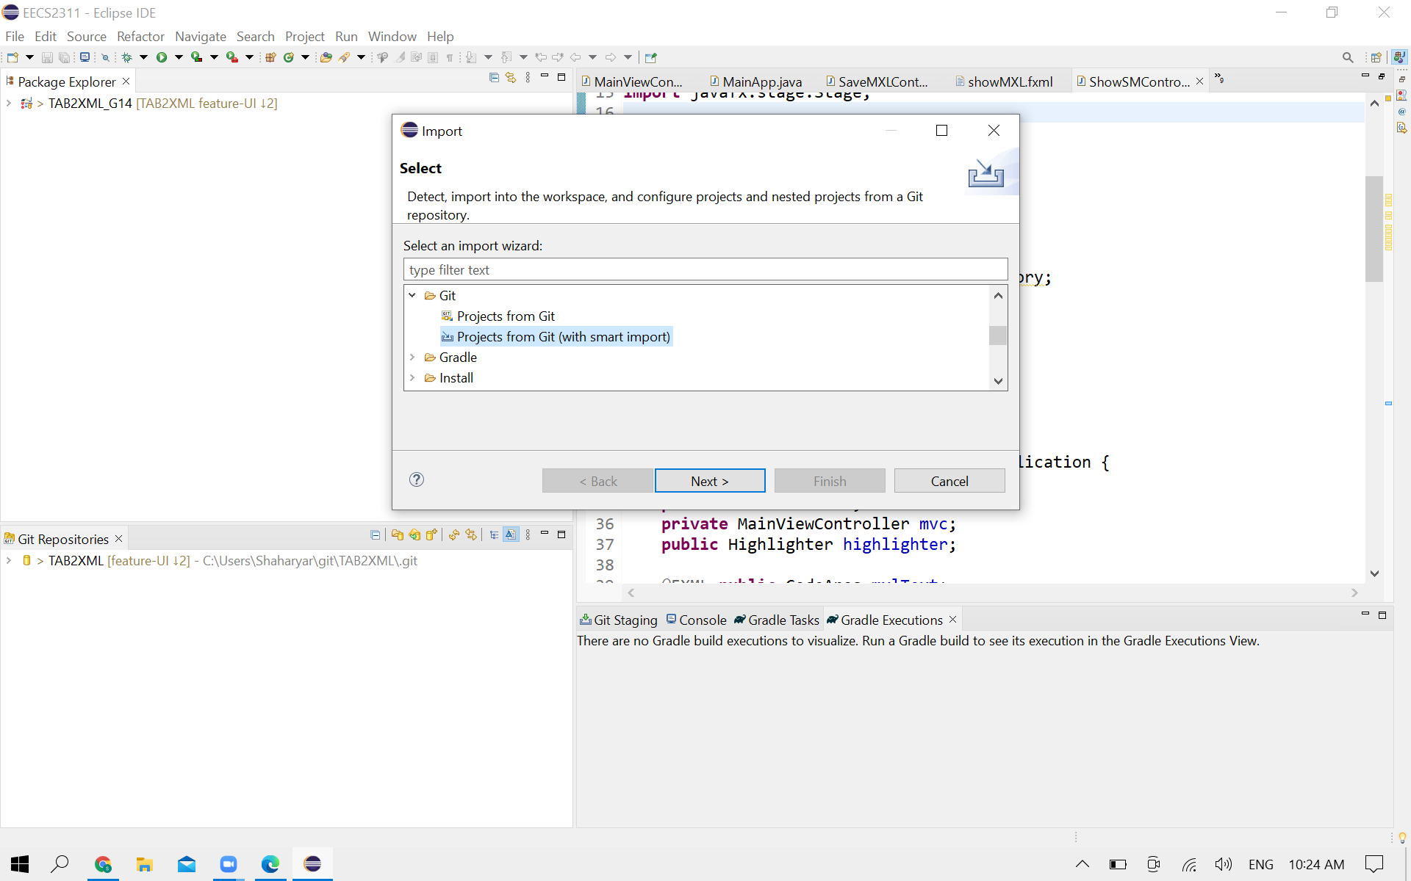

1. Copy the URL of the program and then select the “Clone URL” option

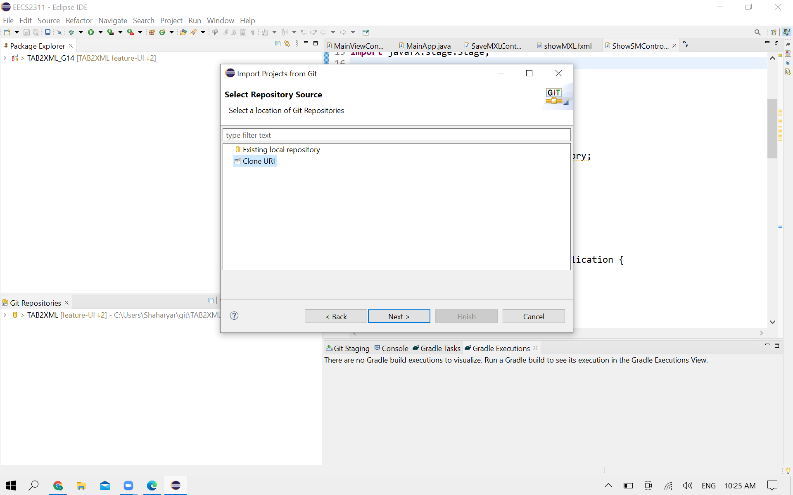

1. Make sure the URL is correct and fill in your authentication details.

Your user must be your registered name in the Github account, and

your password must be the Access Token that you can procure from

Github.

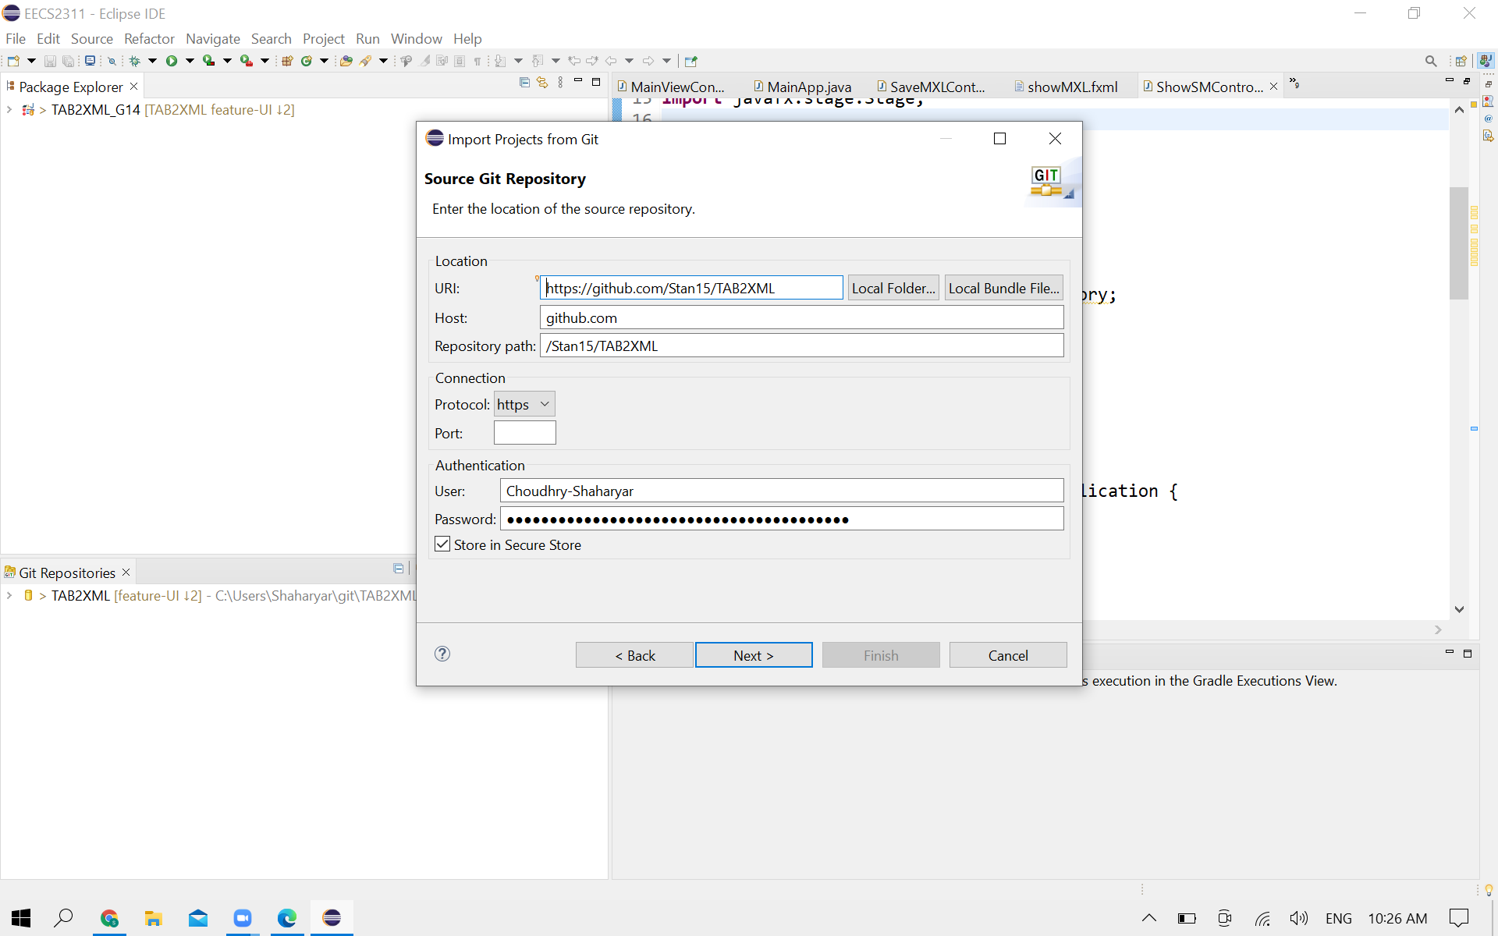

1. Choose the directory where you want the application installed.

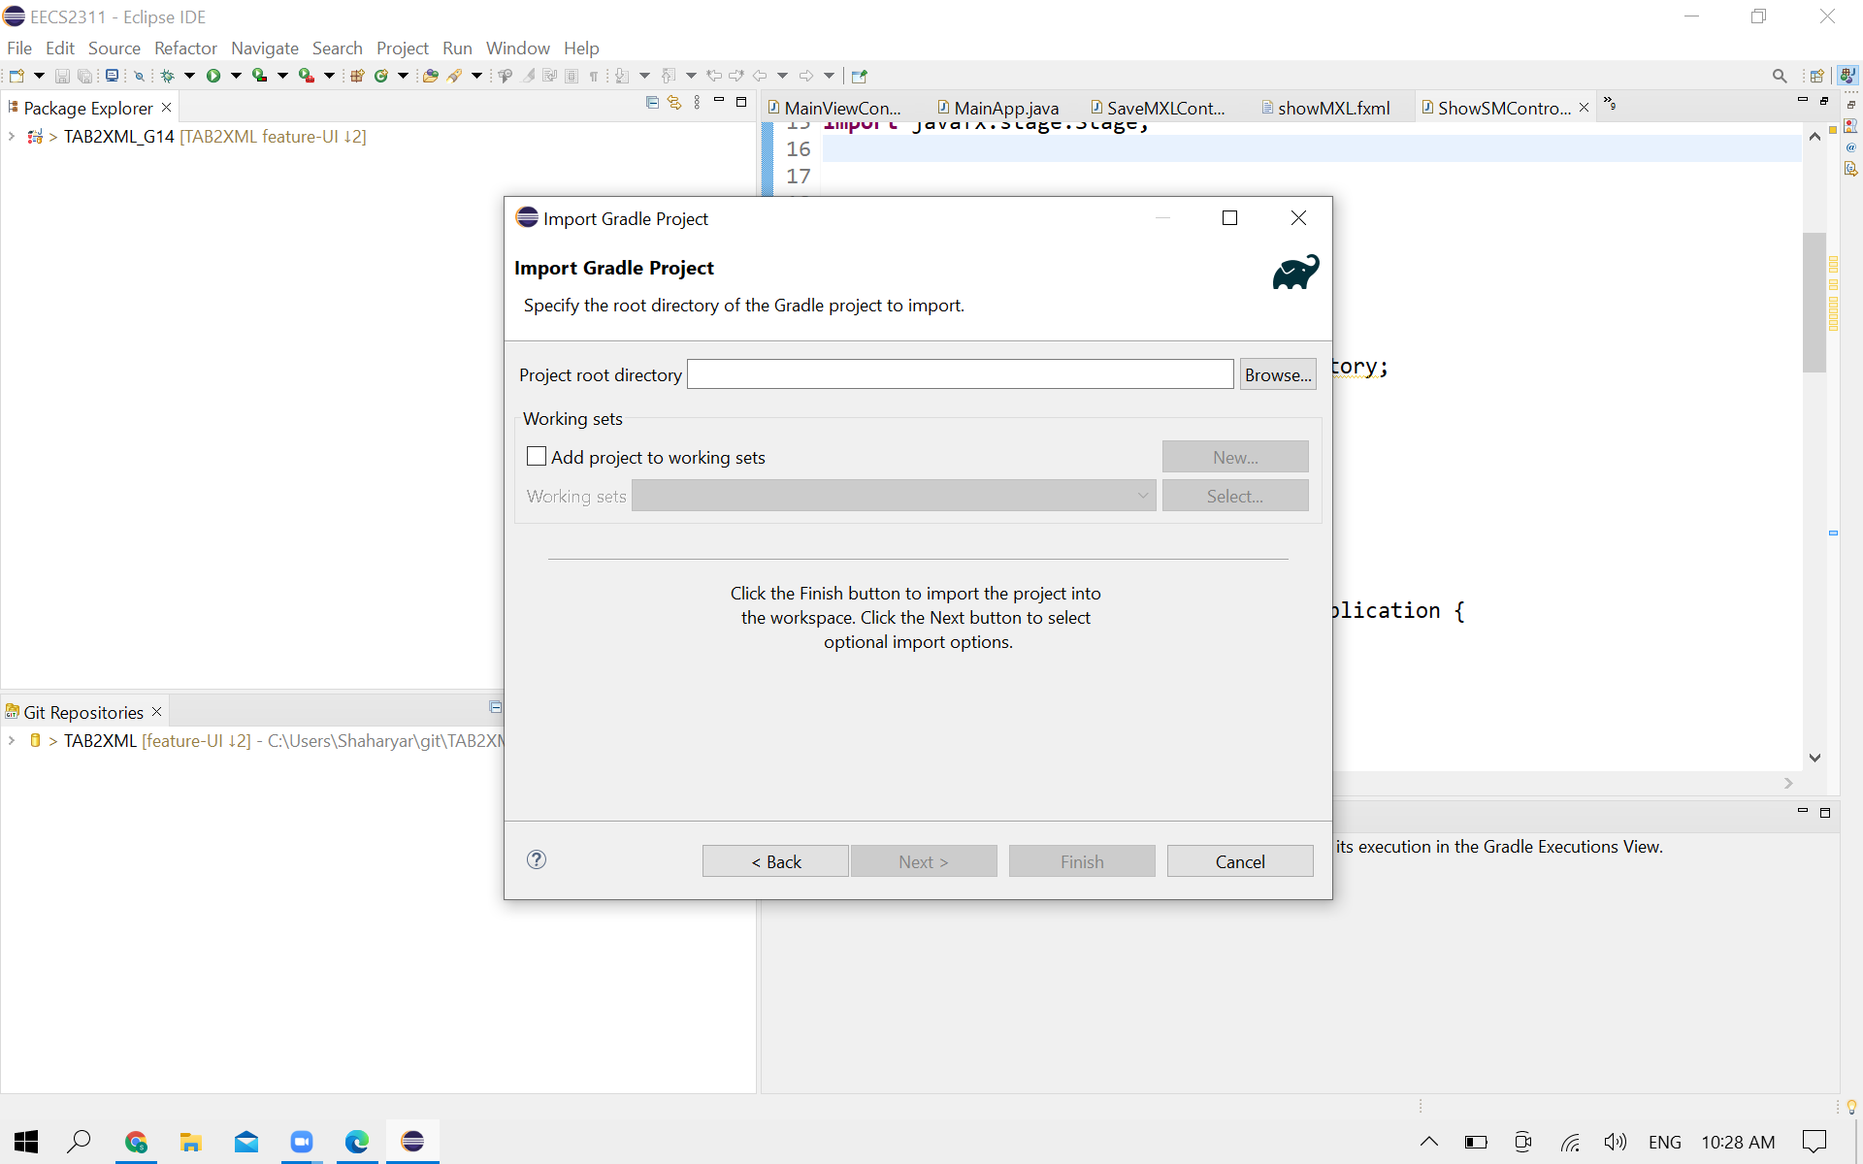

1. Open the Gradle tasks window, and click run to start the program

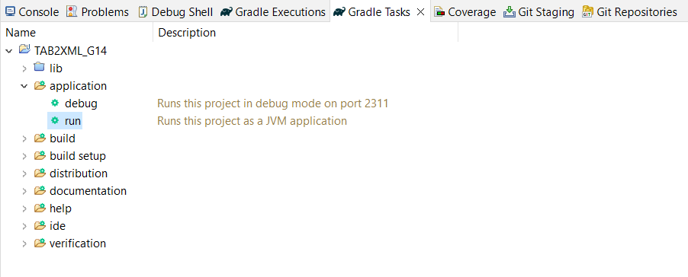

# Common Use Cases

When you run the program, you will be able to see a text field at the center of screen (Figure1). This is where you paste in your tablature txt file.

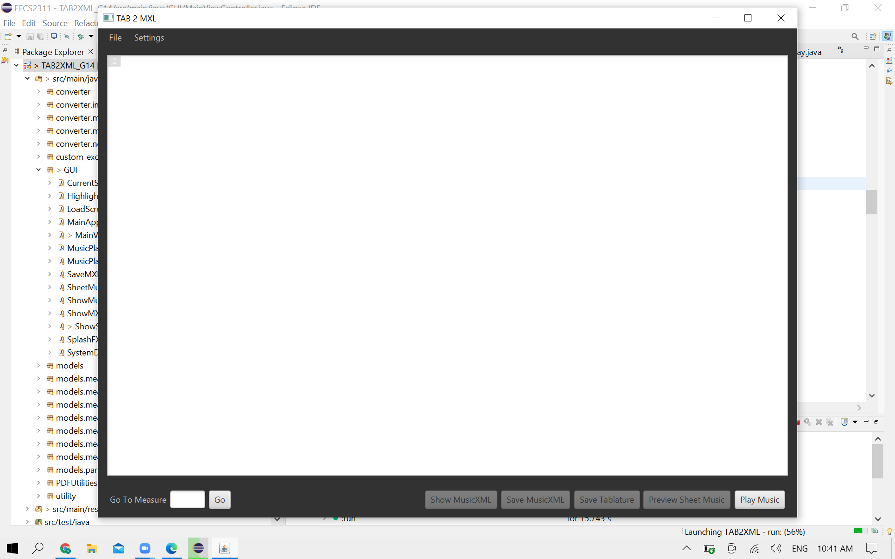

To put your input, click file-open and choose your file, or copy and paste your text file in text field.

3. Once you put your text input, the system identifies errors in your input if any exists, and it notates them using a color-coded highlighting system.

There are 4 levels of highlighting:

i. Red highlight: This is used to identify errors which may critically affect the output of the conversion.

ii. Yellow highlight: Errors with this highlight are less critical, but we do not guarantee seeing an accurate output with these errors.

iii. Grey highlight: This highlight is used to identify content which may have little to no effect on the output.

Detailed below are a few examples of different error highlighting scenarios:

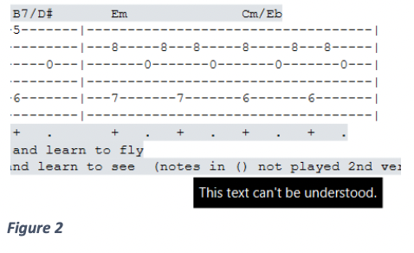

Yellow highlight: “A guitar measure should have 6 lines.” (Figure 3).

As a warning, if you get such an error on a measure which seems to be accurate, make sure no text is written on the side of the measure as this makes the system identify it as two different measures. Reference the Input Requirements section of this manual for more information regarding this.

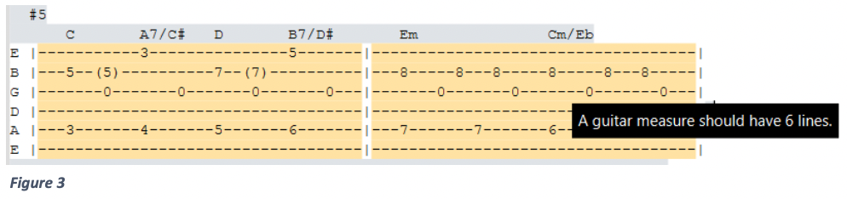

Red highlight: “This annotation is either unsupported or invalid” This is used to identify elements which are either not supported or not identified as valid measure annotations.

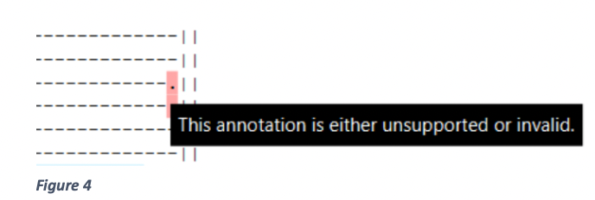

Note: There are more error scenarios which may occur, but they are all categorized into the three groups identified above.

4. For a more accurate output, be sure to resolve any errors highlighted red or yellow. The grey errors can usually be ignored without consequence.

How to resolve errors:

Be sure the number of lines of the instrument is right.

Remove all unrecognizable notations in tablature and replace with dash ‘-’. Remove all text placed around measures, except for measure instructions (time signature and repeats)

Note: If you removed all yellow and red highlights, the score is ready to be converted. However, if there are no yellow or red highlights in the score, you can skip this step.

5. Click the “Convert” button. This opens new window for some option (Figure5).

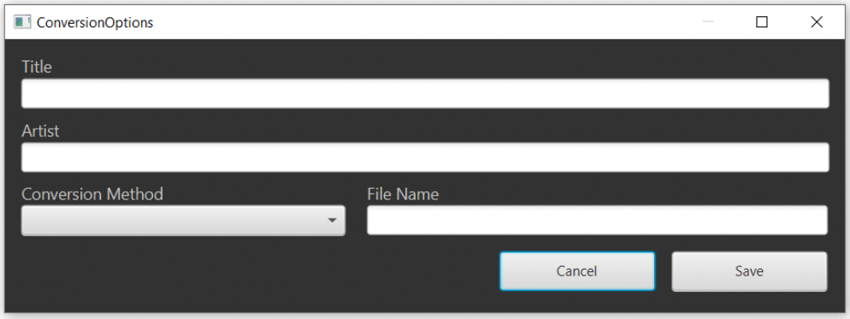

Title – You can set the title of the song.

Artist – You can set the artist’s name.

Conversion Method – You can choose your score type. Piano or Tablature type.

File Name – You can name your file.

Note: All the functions have not been implemented. It will be updated gradually. If you set all of them, click the save button.

6. If you set all of them, click the save button. Navigate to the location where you want to save your converted file and save it. You can also change the file name.

7. You are also able to save the music tab text in a .txt file. After inputting your text, click file, then save as to save the file

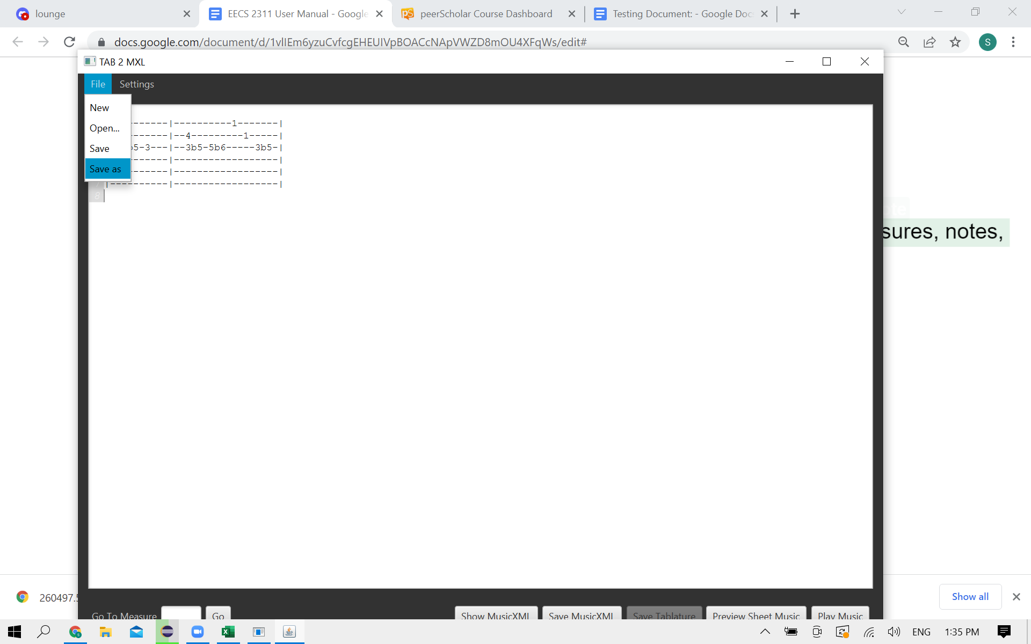

8. If you want to play music, click the “Play Music” button and a music player will be brought up. In this new GUI, all of the information about the music will be displayed in a text area with a scroll bar. The information includes measure numbers, divisions, keys, notes, chords, pitches, and more. To play the music, click the “Play” button at the bottom of the GUI.

You must enter valid text tab input otherwise the program will display a message telling you to change your input.

9. If you want to display music sheet tablature, click “Preview Sheet Music” button, and a new window will appear separate from the main GUI displaying the sheet music derived from the original text tablature.

10.a. You can also open the sheet music as a PDF document using the “Open as PDF button.”

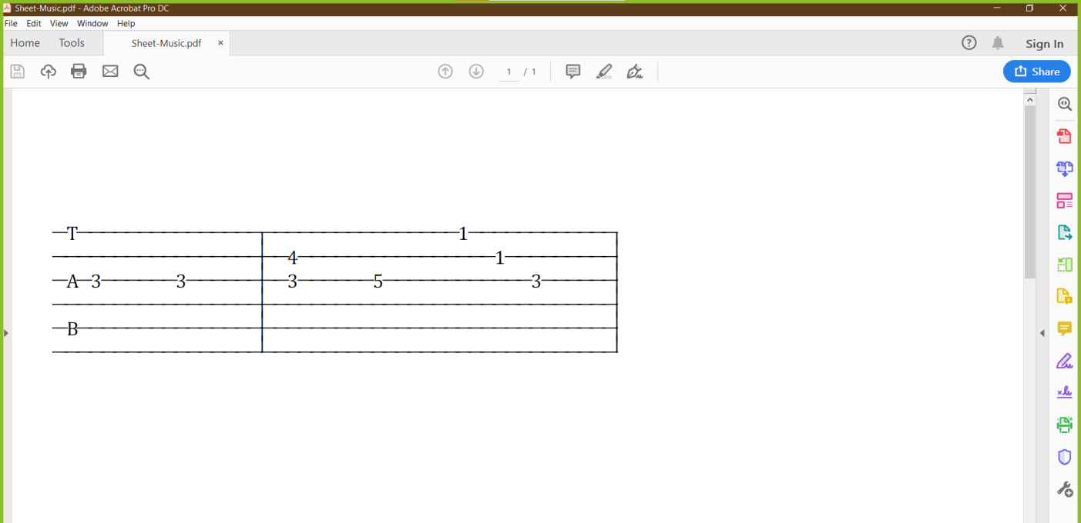

10.b. To save the PDF to your machine click the “Save as PDF” button. This will open a new window where you can customize the file name.

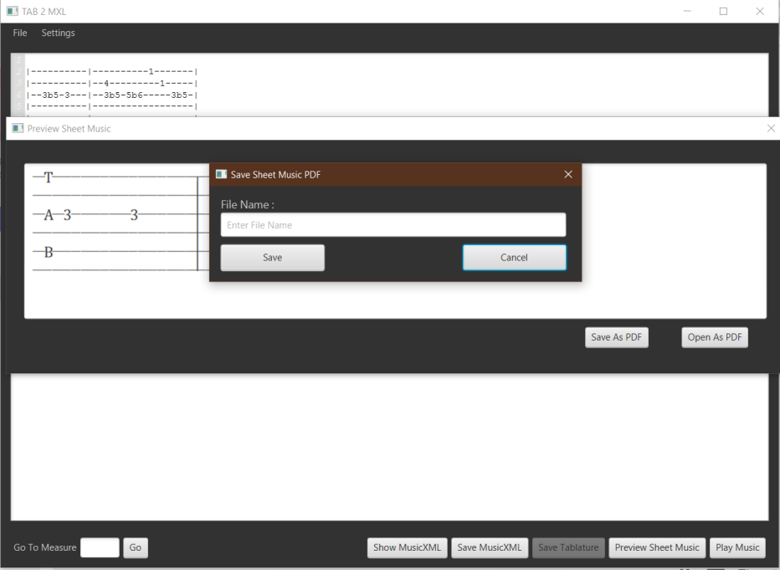

# Input Requirements

## 5.1 Measure instructions (Repeats and time signature)

This program allows for the application of repeats and time signatures to individual measures. He re, we will go over the input restrictions governing these features.

For instructions in general, the following requirements are outlined:

1. For a line to be interpreted as having instructions, it must only be composed of valid instructions separated by spaces and nothing else.

2. The ‘tab’ button should not be used in your instruction lines as this might result in the system not applying the instructions to the correct measure.

3. For your instructions to be recognized, the line directly below the instruction line must be a measure line or another instruction line (instruction chaining is allowed).

4. Lines of instructions are chained by connecting the lines by one new line.

5. The order of priority for applying instructions is left to right, up to down.

Repeats:

For repeats, the following input requirements must be followed for repeats to be correctly applied

1. Repeats must start and end with a vertical bar, and can have any combination of spaces or dashes “-“ in-between, as seen below.

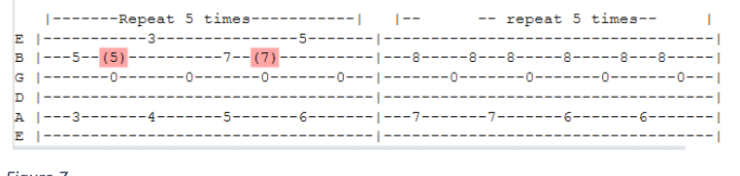

1. Repeats can be notated in any one of the three below stated ways.

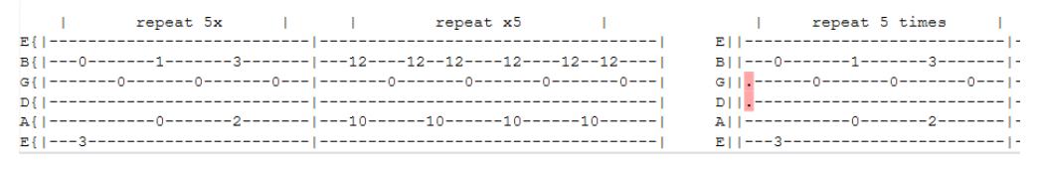

Time Signatures:

1. The list of possible time signatures has been artificially restricted to the following generally accepted time signatures: 2/4, 2/2, 3/8, 3/4, 4/8, 4/4, 4/2, 6/8, 6/4, 9/8, 9/4, 12/8, and 12/4.
2. If an invalid time signature is provided, the following error is received:

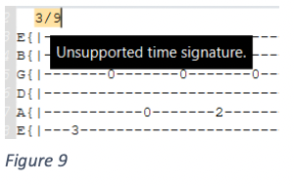

1. The default time signature is 4/4 if no time signature instruction is provided.
2. Time signatures with a beat or beat count consisting of three or more values are not recognized as instructions and will make the line of instructions invalid.

Note Player:

You can also select measures and play them through our note player:

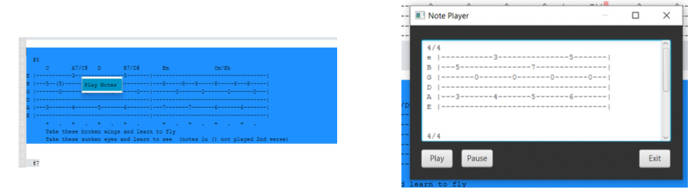

## 5.2 Guitar

Some sample tablature text files that meet the below requirements can be found in the project folder in the directory TAB2XML/src/test/resources/test_tab_files. The tablature file input into the program must meet the following requirements:

1. A measure must start with a vertical line after the string name.

2. you may not have text by the side of a measure which itself is not a measure.

Note: System does not guarantee an accurate output if measure collections do not contain blank line dividing, and if they do not have clear line names specified. (i.e string names/drum names).

Note: Information of other instruments will be updated gradually.